Official league roster - BASKETBALL
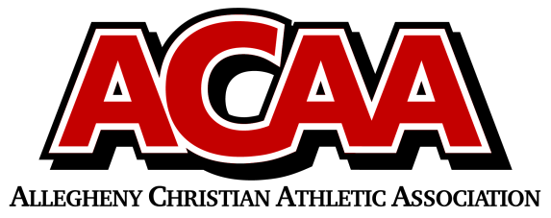
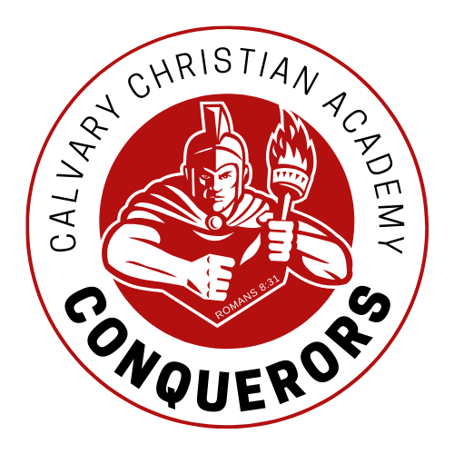
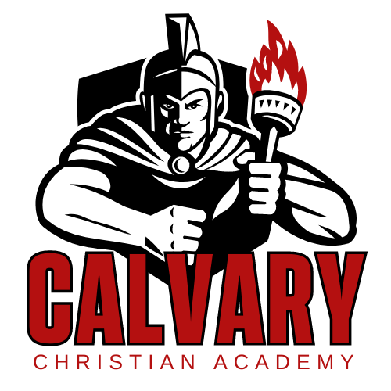

School Name: Calvary Christian Acad.
Team Colors: red/gold/white
Overall Wins ___ Losses ____ Ties ___
ACAA Wins ___ Losses ____ Ties ___ OPPONENT: __________________________
Date: _________
Number | Name | Year | Position | Height | Homeschool
13 | Maddie Ayers | Sr.
11 | Bethany Suttles | Sr.
12 | Eva Penning | Sr.
25 | Andrea Schroeder | Sr.
22 | Hannah Duerkson | Jr. |  |  | X
33 | Kelsie Taylor | So.
21 | Olivia Mills | F
2 | Shakia Lapp | F
3 | Shantae Lapp | 8th
MGR | Ava Fox | F
 | *Denotes team captain

Head Coach: Dustin Shriner
Asst. coach: jim anderson
Asst. coach: kristen haertlein

Official ACAA League Team Roster. to be submitted to the scorer’s table before each game.

